CSA6303 - THREAT INTELLIGENCE AND NETWORK SECUR
Assessment Tool 1: CONCEPT MAPPING
Faculty : Dr.V.Parthipan SLOT A

Topics: Network Security Fundamentals | Security Goals (CIA Triad) | Types of Network Threats |Introduction to Threat Intelligence Types of Threat Intelligence (Strategic, Tactical, perational) — Threat Intelligence Lifecycle — Applications in IT Industry
CO1: Interpret security principles, network threats, and the role of threat intelligence in cybersecurity.

Total: 50
Student Name : Keerthipati Hema Sree
Register number: 192411156

Code of Conduct:

I keerthipati Hema Sree, 192411156 (Name / Reg No) certify that this submission is my original work and that I have adhered to the guidelines specified for this assessment. I understand that any violation of academic integrity rules will result in disciplinary action.

Signature of the student
keerthipati Hema Sree
CO1 – Concept Mapping Questions
No. | Concept-Mapping Question
1 | Construct a comprehensive concept map explaining the foundations of Network Security. Connect network security fundamentals with security objectives, the CIA Triad (Confidentiality, Integrity, and Availability), network assets, vulnerabilities, threats, and protective measures, and explain how these concepts collectively support secure network operations.
2 | Develop a concept map illustrating the CIA Triad as the foundation of network security. Relate Confidentiality, Integrity, and Availability to different types of network threats and demonstrate how a single threat can affect one or more security goals.
3 | Construct a concept map classifying different types of Network Threats and their potential impact on security goals. Connect threats such as malware, phishing, denial-of-service, spoofing, eavesdropping, and unauthorized access with the CIA Triad and explain the resulting security implications.
4 | Develop an integrated concept map connecting Network Security Fundamentals, Network Threats, and Threat Intelligence. Show how identifying assets, vulnerabilities, and threats leads to the collection and analysis of threat information and ultimately supports informed security decisions.
5 | Construct a concept map explaining the concept of Threat Intelligence and its role in modern network security. Relate threat actors, indicators, vulnerabilities, attack patterns, threat information, analysis, and actionable intelligence to demonstrate how Threat Intelligence helps organizations anticipate and respond to network threats.
6 | Develop a comparative concept map of Strategic, Tactical, and Operational Threat Intelligence. Connect each type with its purpose, target audience, time horizon, information requirements, decision-making process, and appropriate network-security use cases, and analyze how the three intelligence types complement one another.
7 | Construct a concept map representing the complete Threat Intelligence Lifecycle. Connect planning/direction, collection, processing, analysis, dissemination, and feedback with the identification of network threats and security requirements, showing how feedback continuously improves the intelligence process.
8 | Develop an end-to-end concept map showing how a network threat progresses from identification to actionable Threat Intelligence. Connect network security fundamentals, CIA security goals, threat detection, intelligence collection, processing, analysis, dissemination, and response, and explain the relationship between each stage.
9 | Create a scenario-based concept map for an organization experiencing a major network attack. Integrate the CIA Triad, types of network threats, Strategic Intelligence, Tactical Intelligence, Operational Intelligence, and the Threat Intelligence Lifecycle to demonstrate how the organization can understand, prioritize, and respond to the threat.
10 | Design a comprehensive concept map demonstrating the applications of Network Security and Threat Intelligence in the IT industry. Connect network security fundamentals, CIA Triad, network threats, Threat Intelligence, Strategic/Tactical/Operational Intelligence, and the Threat Intelligence Lifecycle with applications such as threat monitoring, incident response, vulnerability management, risk assessment, security operations, and organizational decision-making.

Recommended Bloom's Levels
- Analyze (L4): Q1, Q2, Q3, Q4, Q5, Q7, Q8
- Evaluate (L5): Q6, Q9
- Create (L6): Q10
These questions are deliberately framed so that students must connect concepts in a hierarchy/relationship map, rather than simply reproduce definitions.

Q3. Types of Network Threats and Their Impact on Security Goals (CIA Triad)
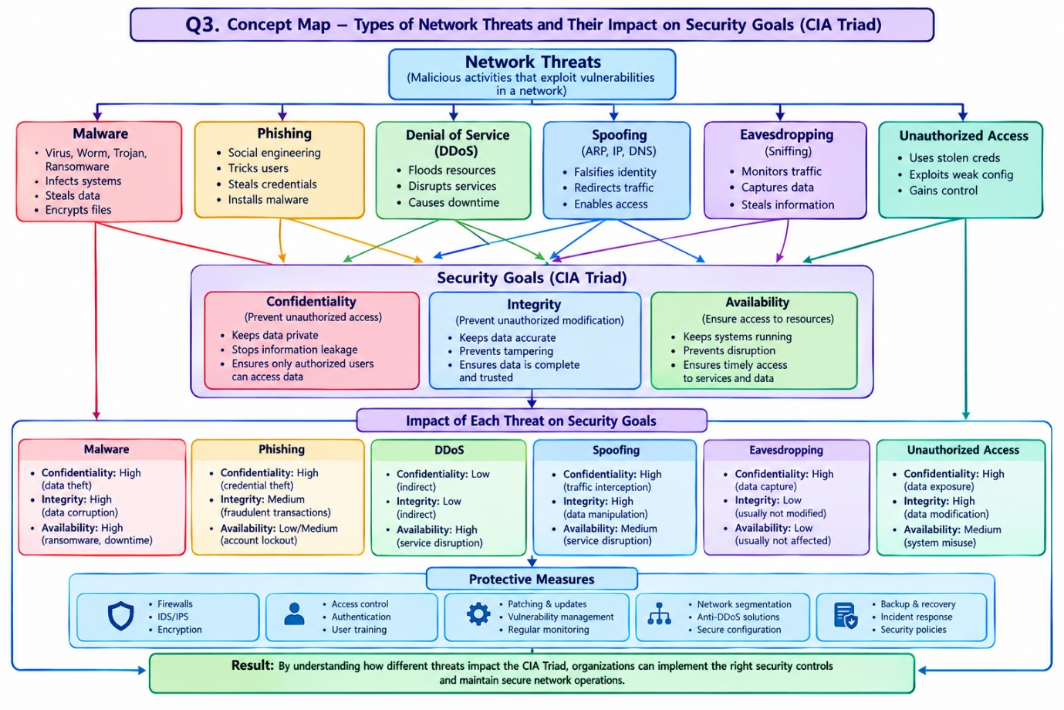
1. Network Threats
- Malicious activities that exploit network vulnerabilities.
- Threaten the confidentiality, integrity, and availability of information.
2. Types of Network Threats
- Malware: Viruses, worms, Trojans, ransomware — infects systems, steals data, and encrypts files.
- Phishing: Social engineering — tricks users into revealing credentials or installing malware.
- Denial of Service (DoS/DDoS): Floods network resources and disrupts services.
- Spoofing: ARP, IP, and DNS spoofing — falsifies identity and redirects traffic.
- Eavesdropping: Sniffing network traffic to capture confidential information.
- Unauthorized Access: Uses stolen credentials or weak configurations to access systems.
3. Security Goals — CIA Triad
- Confidentiality: Protects information from unauthorized access.
- Integrity: Prevents unauthorized modification of data.
- Availability: Ensures systems and services remain accessible.
4. Impact of Threats on CIA Triad
- Malware → Confidentiality, Integrity, and Availability.
- Phishing → Confidentiality and potentially Integrity.
- DoS/DDoS → Availability.
- Spoofing → Integrity and potentially Confidentiality.
- Eavesdropping → Confidentiality.
- Unauthorized Access → Confidentiality, Integrity, and potentially Availability.
5. Protective Measures
- Firewalls and IDS/IPS.
- Encryption and secure protocols.
- Access control and multi-factor authentication.
- Regular patching and vulnerability management.
- Network segmentation and user awareness training.
- Backup, recovery, and incident response.
Result: Understanding the relationship between network threats and the CIA Triad helps organizations select suitable security controls and maintain secure network operations.

Q4. Network Security Fundamentals, Network Threats, and Threat Intelligence
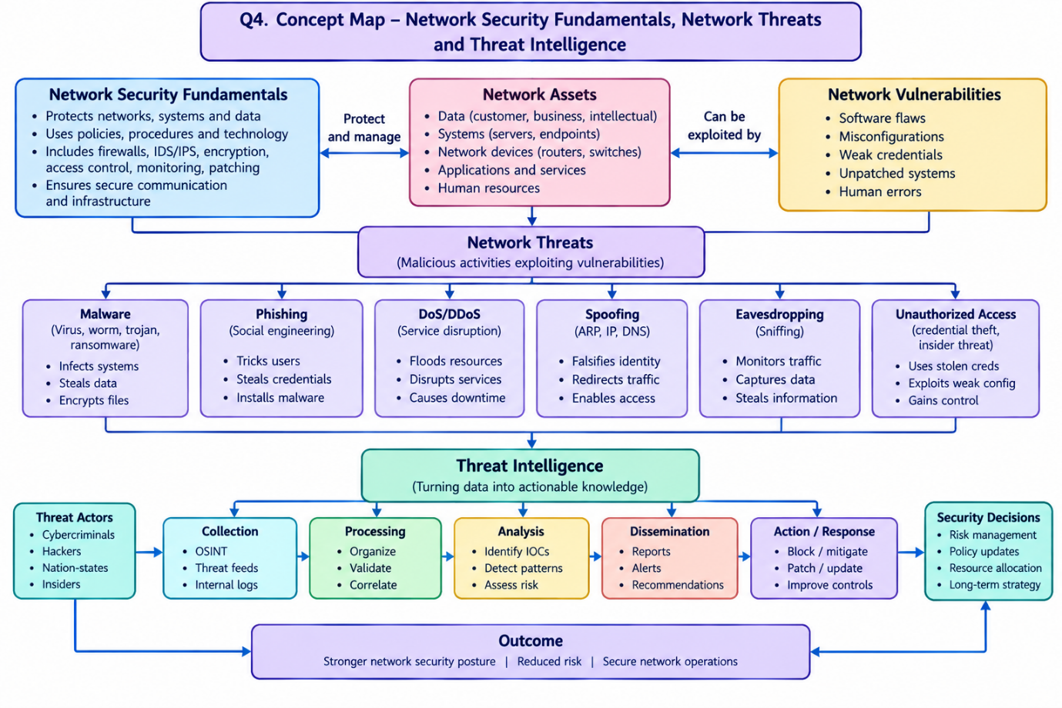
Concept Map Content
1. Network Security Fundamentals
- Protects networks, systems, and data.
- Uses security policies, procedures, and technologies.
- Includes firewalls, encryption, access control, monitoring, and patching.
- Ensures secure communication and infrastructure.
2. Network Assets
- Data: Customer, business, and intellectual property.
- Systems: Servers and endpoints.
- Network devices: Routers and switches.
- Applications and services.
- Human resources.
3. Network Vulnerabilities
- Software flaws.
- Misconfigurations.
- Weak credentials.
- Unpatched systems.
- Human errors.
4. Types of Network Threats
- Malware: Infects systems, steals data, and encrypts files.
- Phishing: Steals credentials through deceptive messages.
- DoS/DDoS: Disrupts services by overwhelming resources.
- Spoofing: Falsifies identities and redirects traffic.
- Eavesdropping: Captures confidential communications.
- Unauthorized Access: Exploits stolen credentials or weak security.
5. Threat Intelligence
- Converts raw threat information into actionable knowledge.
- Identifies threat actors, attack patterns, and indicators of compromise (IOCs).
- Helps organizations understand and anticipate cyberattacks.
6. Threat Intelligence Process
- Collection: Gather OSINT, threat feeds, and internal logs.
- Processing: Organize, validate, and correlate collected data.
- Analysis: Identify IOCs, detect patterns, and assess risks.
- Dissemination: Share reports, alerts, and recommendations.
- Action/Response: Block threats, patch vulnerabilities, and improve security controls.
7. Security Decisions
- Prioritize risks.
- Update security policies.
- Allocate security resources.
- Plan incident response.
- Improve preventive and corrective controls.
8. Outcomes
- Early threat detection.
- Reduced cybersecurity risks.
- Faster incident response.
- Improved network resilience.
- Secure and reliable network operations.
Result: Integrating network security fundamentals with threat intelligence helps organizations identify vulnerabilities, understand threats, make informed security decisions, and strengthen their overall cybersecurity posture.

